AI STUDYBUDDY
AI-POWERED BACKEND API FOR STUDY MATERIAL SUMMARIZATION, FLASHCARDS, QUIZZES & PERSONALIZED STUDY PLANS

PROJECT DOCUMENTATION

Submitted By:

Team ID: SWTID-2026-6718
Team Size: 4
Team Leader: Gous Basha S
Team Member: Rithish Kumar J
Team Member: Sai Gowtham M
Team Member: D Santhosh

Date: 27 September 2026
Team SWTID-2026-6718

1. ABSTRACT
AI StudyBuddy is an AI-powered backend REST API developed to help students convert their own study material into revision-ready content. The application is built using Node.js, Express.js, MongoDB, Mongoose, JWT authentication, bcrypt password hashing, and Google Gemini 2.5 Flash.
The system supports two user roles: Student and Admin. Students can upload study material (.txt, .md, .pdf), and generate AI-powered summaries, flashcards, quizzes and personalized study plans from that material. Admins can list users, delete users along with their materials, and view aggregate platform statistics.
Google Gemini 2.5 Flash is integrated to automatically summarize material, generate flashcards and MCQ quizzes, and build a day-wise study plan based on a stated goal, available hours per day, and number of days. The application follows a layered, modular architecture — routes, controllers, models, middleware and utilities — and Postman is used to test and demonstrate the REST APIs.

2. INTRODUCTION
Exam preparation and revision are important parts of a student's academic life, but converting raw study material — notes, PDFs, and text documents — into revision-ready formats such as summaries, flashcards and self-test quizzes is time-consuming when done manually.
Traditional study workflows require students to manually re-read material, write their own flashcards and test questions, and plan their limited study time across several subjects. This approach does not scale well when exams approach and time is limited.
AI StudyBuddy addresses this by combining backend development with Generative AI. Google Gemini 2.5 Flash is used to generate summaries, flashcards, quizzes and personalized study plans directly from material the student has already uploaded, removing much of the manual effort involved in revision preparation.
The project is implemented as a backend REST API, accessible through a bundled lightweight HTML/CSS/JS frontend or through tools such as Postman.

3. PROJECT TITLE

AI StudyBuddy

Project Theme
AI-Powered Backend REST API for Study Material Summarization, Flashcard & Quiz Generation, and Personalized Study Planning

4. PROJECT DESCRIPTION
AI StudyBuddy is a secure, intelligent REST API platform designed to help students study more efficiently.
The system uses Node.js and Express.js for backend development, and MongoDB with Mongoose for database management. Google Gemini 2.5 Flash is integrated to provide AI-assisted summarization, flashcard generation, quiz generation and study-plan generation.
The application supports two user roles:
- Student
- Admin
Students can register, log in, upload study material, and request AI-generated summaries, flashcards, quizzes and study plans for their own material. Admins have oversight of registered users and platform usage statistics.

5. PROBLEM STATEMENT
Traditional revision workflows present several challenges.

5.1 Manual Summarization
Reading and condensing long notes or PDFs into a usable summary takes considerable time.

5.2 Manual Flashcard & Quiz Creation
Students must manually write their own flashcards and self-test questions from memory.

5.3 Study Planning
Dividing limited study hours across multiple subjects/topics is difficult to plan manually and is often abandoned.

5.4 Scattered Material & Access Control
Study material is often scattered across tools with no secure, centralized place to keep it, and no distinction between student and admin access.

5.5 Security Issues
Backend applications handling personal study data require authentication, authorization, and password protection.

6. PROPOSED SOLUTION
AI StudyBuddy provides a centralized backend platform that combines study-material management with Artificial Intelligence.
The proposed system provides:
- Secure user registration and login
- JWT authentication (access + refresh tokens)
- Role-Based Access Control (Student / Admin)
- Study material upload, listing, viewing and deletion
- AI-powered summarization
- AI-powered flashcard generation
- AI-powered quiz generation
- AI-powered personalized study-plan generation
- Admin user and platform management

7. OBJECTIVES

7.1 Primary Objectives
- To develop a backend REST API for study-material management.
- To implement secure authentication using JWT.
- To implement role-based authorization for Student and Admin.
- To provide complete material upload/list/view/delete operations.
- To integrate Google Gemini 2.5 Flash.
- To generate AI summaries, flashcards and quizzes from uploaded material.
- To generate a personalized AI study plan.

7.2 Secondary Objectives
- To improve revision efficiency for students.
- To reduce manual effort in content summarization and self-testing.
- To provide controlled access to different types of users.
- To maintain a secure backend environment.
- To provide a testable and modular REST API.

9. SYSTEM REQUIREMENTS

9.1 Software Requirements
Component | Requirement
Operating System | Windows 10/11, macOS or Linux
Runtime | Node.js
Backend Framework | Express.js
Database | MongoDB
ODM | Mongoose
Authentication | JWT
Password Security | bcryptjs
File Upload | Multer
AI Service | Google Gemini 2.5 Flash
API Testing | Postman
IDE | Visual Studio Code

9.2 Hardware Requirements
- Intel Core i5 8th Generation or above, or equivalent
- Minimum 8 GB RAM (16 GB recommended)
- Minimum 1 GB available project storage
- Internet connection for the Gemini AI service

10. TECHNOLOGY USED

10.1 Node.js
Provides the runtime environment for executing the backend application.

10.2 Express.js
Used to create REST APIs, route requests, and handle middleware.

10.3 MongoDB
Document-oriented database used to store users and study materials.

10.4 Mongoose
Used to define schemas, models, validation rules, and database operations.

10.5 JWT
JSON Web Tokens are used for authentication and protected API access.

10.6 bcryptjs
Used to securely hash user passwords.

10.7 Multer
Middleware used to handle multipart file uploads for study material.

10.8 Google Gemini 2.5 Flash
Provides Generative AI functionality for summarization, flashcards, quizzes and study plans.

10.9 Postman
Used for REST API testing and demonstration.

11. SYSTEM ARCHITECTURE
The application follows a layered backend architecture: an Express server, authentication and role middleware, controllers, a Mongoose database layer, and an AI flow connected to Gemini-based services.
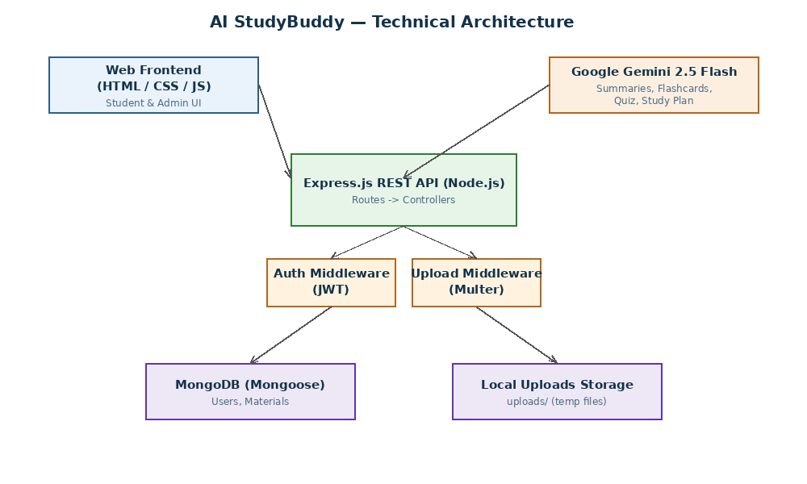
Figure 1: System Architecture of AI StudyBuddy

12. LAYERED (MVC-STYLE) ARCHITECTURE

12.1 Model Layer
Models include:
- User
- Material

12.2 Controller Layer
Controllers include:
- Authentication Controller
- Material Controller
- Admin Controller

12.3 Routing Layer
The Routing Layer defines the REST API endpoints and connects requests to controller functions.

12.4 Middleware & Utility Layer
Includes authentication/role middleware, upload middleware (Multer), the database connection utility, the Gemini AI utility, and the token utility.
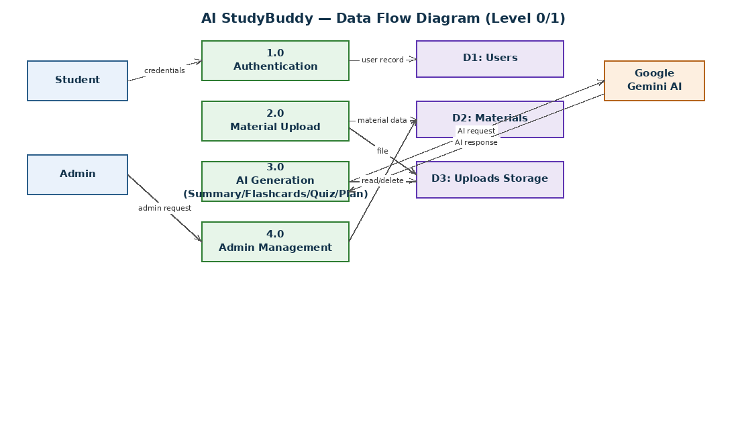
Figure 2: AI StudyBuddy Data Flow / Module Structure

13. DATABASE DESIGN
MongoDB is used as the primary database. The main collections are:
- Users
- Materials

14. USER ENTITY
The User entity stores information about registered users.
Field | Description
_id | Unique user identifier
name | User's name
email | Unique email address
password | Hashed password
role | student or admin (default: student)
createdAt / updatedAt | Timestamps

15. MATERIAL ENTITY
The Material entity stores uploaded study material and its AI-generated outputs.
Field | Description
_id | Material identifier
user | Reference to the owning User
title | Material title
content | Extracted raw text content
filename | Original uploaded file name
summary | AI-generated summary
flashcards | Array of { question, answer }
quiz | Array of { question, options, answer }
studyPlan | AI-generated study plan text
createdAt / updatedAt | Timestamps

16. ENTITY RELATIONSHIP DIAGRAM
The main relationship is: one User can create multiple Materials.
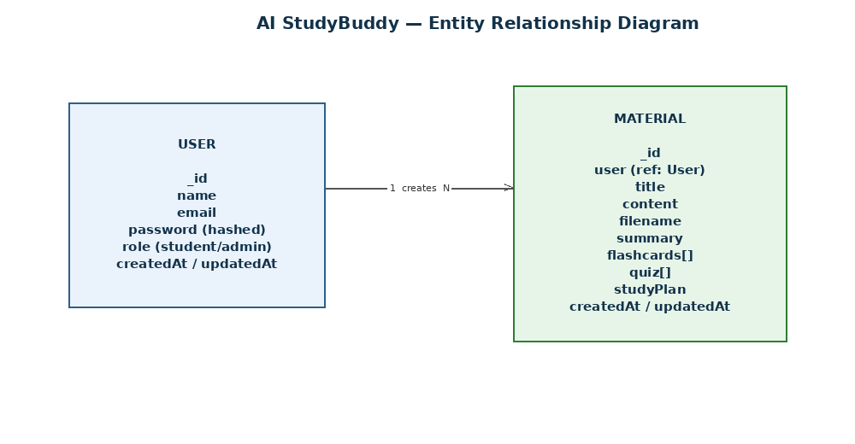
Figure 3: Entity Relationship Diagram of AI StudyBuddy

17. USER ROLES AND RESPONSIBILITIES

17.1 Student
Registers, logs in, uploads study material, and generates AI summaries, flashcards, quizzes and study plans for their own material.

17.2 Admin
Views all registered users, deletes users (cascading their materials), and views aggregate platform statistics.

18. ROLE-BASED ACCESS CONTROL
Role-Based Access Control (RBAC) restricts operations according to the authenticated user's role. The implemented project uses the protect and adminOnly middleware to enforce these permissions.
Operation | Student | Admin
Upload / View / Delete Own Material | ✓ | ✗
Generate AI Summary / Flashcards / Quiz / Plan | ✓ | ✗
List All Users | ✗ | ✓
Delete Any User | ✗ | ✓
View Platform Statistics | ✗ | ✓

19. AUTHENTICATION AND JWT

Registration
POST /api/auth/register
A new account is created and the password is securely hashed before storage.

Login
POST /api/auth/login
The system verifies credentials and generates JWT access (15 min) and refresh (7 days) tokens.

Protected Requests
Authorization: Bearer <JWT_TOKEN>
The JWT identifies the authenticated user and allows protected operations to be accessed according to role permissions.

20. STUDY MATERIAL MANAGEMENT
AI StudyBuddy provides complete material lifecycle management.

Material APIs
POST /api/materials/upload
GET /api/materials
GET /api/materials/:id
DELETE /api/materials/:id
Ownership protection ensures that students can manage only their own materials.

21. GOOGLE GEMINI AI INTEGRATION
Google Gemini 2.5 Flash is used to provide AI-assisted content generation from a student's uploaded material.
The project defines the following AI endpoints:
POST /api/materials/:id/summarize
POST /api/materials/:id/flashcards
POST /api/materials/:id/quiz
POST /api/materials/:id/study-plan

22. AI SUMMARIZATION
The summarization endpoint generates a concise summary from the material's content.

API
POST /api/materials/:id/summarize

Output
{
"summary": "Concise summary..."
}

23. AI FLASHCARD GENERATION
The flashcard endpoint accepts a desired count and generates that many question/answer pairs from the material.

Request
{
"count": 5
}

Response
{
"flashcards": [
{ "question": "...", "answer": "..." }
]
}

24. AI QUIZ GENERATION
The quiz endpoint generates multiple-choice questions with options and the correct answer.

Request
{
"count": 5
}

Response
{
"quiz": [
{ "question": "...", "options": ["A","B","C","D"], "answer": "A" }
]
}

25. AI STUDY PLAN GENERATION
The study-plan endpoint generates a day-wise plan based on a stated goal, hours available per day, and the number of days, combined with the material content.

Request
{
"goal": "Cover all chapters before the exam",
"hoursPerDay": 3,
"days": 5
}

Response
{
"studyPlan": "Day 1: ... \nDay 2: ..."
}

26. PROMPT ENGINEERING
Prompt engineering is used to provide structured instructions to Google Gemini for each AI feature.
Material Content / Parameters
↓
Structured Prompt
↓
Google Gemini 2.5 Flash
↓
Generated Result (Summary / Flashcards / Quiz / Study Plan)

27. ADMIN MANAGEMENT
GET /api/admin/users
DELETE /api/admin/users/:id
GET /api/admin/stats
Admin routes are protected by both JWT authentication and the adminOnly role check.

28. SECURITY FEATURES

Password Security
Passwords are hashed using bcrypt.

JWT Security
JWT tokens protect authenticated routes.

Role Authorization
RBAC prevents students from accessing admin-only operations.

Centralized Error Handling
A global Express error handler returns consistent error responses instead of crashing the process.

Environment Configuration
Secrets (JWT keys, Gemini API key, Mongo URI) are managed via a .env file and never hard-coded.

29. API MODULE SUMMARY
Module | Main Functionality
Authentication | Registration, Login, Refresh, Logout
Authorization | Student, Admin (JWT role-based)
Material | Upload, List, View, Delete
Gemini AI | Summarize, Flashcards, Quiz, Study Plan
Admin | List Users, Delete User, Platform Stats

30. API TESTING
The backend APIs were tested using Postman. The full test suite and results are documented in the Project Testing Phase (06_Project_Testing/Testing_Phase.docx).

31. TESTING RESULTS
The completed testing verification tested authentication, roles, material management and AI generation.
Reported result: 20 Passed, 0 Failed.

32. SYSTEM FUNCTIONALITY SUMMARY
AI StudyBuddy allows a student to register, log in, upload study material, and instantly generate an AI summary, flashcards, an MCQ quiz, or a personalized study plan from that material — all persisted for later review. Admins can oversee the user base and platform usage.

33. ADVANTAGES
- AI-assisted summarization reduces manual revision effort.
- AI-generated flashcards and quizzes provide instant self-assessment.
- Personalized study plans help students allocate limited time effectively.
- Role-based permissions separate student and admin operations.
- Layered architecture provides modular separation of application responsibilities.
- Postman enables direct backend API testing.

34. LIMITATIONS
- The current system is backend-focused with a minimal bundled frontend.
- AI functionality depends on Google Gemini API availability.
- Uploaded files are stored temporarily on local disk rather than cloud storage.
- A larger production deployment would require additional infrastructure (e.g., cloud storage, managed DB).

35. FUTURE ENHANCEMENTS
- A richer, dedicated frontend/mobile application
- A chat-style Q&A assistant over uploaded material
- Progress analytics and performance dashboards
- Cloud-based file storage (e.g., S3)
- Multi-language content generation
- Collaborative study groups and shared material

36. CONCLUSION
AI StudyBuddy combines backend development, secure authentication, role-based authorization, database management, and Generative AI in a single REST API platform. The system provides practical APIs for study-material management and uses Google Gemini 2.5 Flash to assist with summarization, flashcard generation, quiz generation and personalized study planning. JWT and RBAC provide controlled access to system operations for students and admins.
The project demonstrates the application of modern backend and AI technologies in an intelligent study-assistance system and satisfies the major functional and technical requirements defined for the project.

